The Twin Roman Catholic Parishes of

St. Agnes & St. Anthony

First Sunday of Advent Year A

November 27, 2022

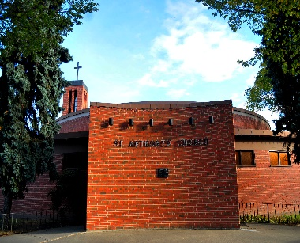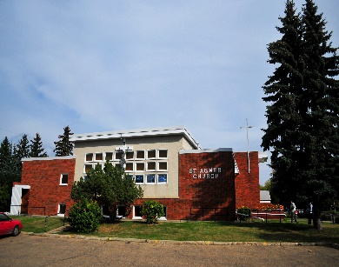

**St. Anthony St. Agnes**

**10661-82 Avenue 10826-62 Avenue**

**Edmonton, AB T6E 2A6 Edmonton, AB T6H 1N1**

**Ph: 780- 432-0611 Ph: 780- 432-0611**

**Fax: 780-434-4969**

**Office Hours: Monday – Friday**

**9:00 am – 12 Noon and 1:00 pm – 4:00 pm**

### E-Mail: [stanthony.edm@caedm.ca](mailto:stanthony.edm@caedm.ca)

Parish website: twinparishes.caedm.ca

**St. Agnes & St. Anthony Joint Mission Statement**

**As sharers in the mission of Jesus Christ, we are committed to spreading the Gospel and building up the kingdom of God in our homes, in our parishes, and in the communities in which we live.**

***************************************************************

**St. Agnes & St. Anthony Parish Staff:**

**Pastor** Rev. Varghese MunduvelilCFIC

Deacon Guy Germain

Deacon Michael Pucylo

Deacon Ramon Morales

Business Manager Don Wong

Administrative Assistant Florentina Suce

Custodian Bruce Huynh

**\*\*\*\*\*\*\*\*\*\*\*\*\*\*\*\*\*\*\*\*\*\*\*\*\*\*\*\*\*\*\*\*\*\*\*\*\*\*\*\*\*\***

**Twin Parishes Financial Pulse**

Full Year

Nov. 19 & 20 Actual YTD Budget

Sunday, Holy Day $ 11,460 $305,465 $332,000

Building Maint. Fund $ 775 $26,815 $30,000

Together We Serve $ 210 $24,531 $30,000

“Bring the whole tithe into the storehouse, that there may be food in my house. Test me in this,” says the LORD Almighty, “and see if I will not throw open the floodgates of heaven and pour out so much blessing that there will not be room enough to store it.” Malachi 3:10

*May God bless you in your response to His love*

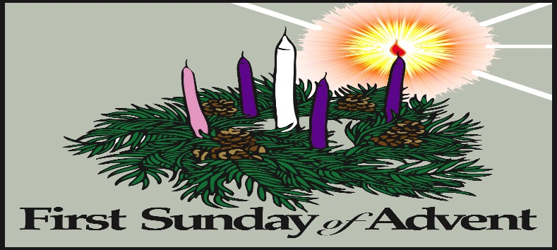

But when the right time came, God sent his Son, born of a woman, subject to the law. God sent him to buy freedom for us who were slaves to the law, so that he could adopt us as his very own children. And because we are his children, God has sent the Spirit of his Son into our hearts, prompting us to call out, “Abba, Father.” Now you are no longer a slave but God’s own child. And since you are his child, God has made you his heir. *Galatians 4:4-8*

******************************************

**Twin Parishes Masses for the Week**

|  |  |
| --- | --- |
| **Tuesday, November 29**  Mass @ St. Anthony | 7:00 pm |
| **Wednesday, November 30**  Adoration @ St. Anthony  Mass @ St. Anthony | 5:00 pm  6:15 pm |
| **Thursday, December 01**  Mass @ St. Agnes | 9:00 am |
| **First Friday, December 02**  Mass @ St. Agnes | 7:00 pm |
| **Saturday, December 03**  Mass @ St. Agnes  Mass @ St. Anthony | 5:00 pm  7:30 pm |
| **Sunday, December 04**  Mass @ St. Agnes  Mass @ St. Anthony  Mass @ St. Agnes | 9:00 am  10:30 am  12 Noon |

To all the parishioners who are interested in having their church donations by automatic withdrawal from their banks please email or call the parish office @ 780-432-0611 to register.

**DONATE BUTTON**

**Parish website: twinparishes.caedm.ca**

**Here are three ways to give:**

**St. Agnes and St. Anthony would prefer if you use:**

[Pre-Authorized Giving Agreement Form](http://twinparishes.caedm.ca/images/Pre-Authorized_automatic_Giving_Agreement_Application.pdf)

**Envelopes** can be dropped off or mailed to the parish office at:

**St. Anthony,**   
**10661-82 Avenue NW Edmonton,**   
**AB T6E 2A6**

**Donate online**: [My-Offering.png](https://29956caedm.thankyou4caring.org/donation-page---donations-to-parishes)

Thank you for being a good steward of

St. Agnes/St. Anthony Parish.

Every gift is truly appreciated.

**ANNOUNCEMENT**

1. If you need a 2023 parish donation envelope please email or contact the parish office to order.
2. Knights of Columbus Pancake Breakfast will be on Sunday, December 4, 2022 at St. Agnes Hall. Cost $7/ per person & $20 for family of four.
3. Advent Penitential Service Tuesday, Dec. 13th at 6:00 PM St. Agnes Church.

**\*\*\*\*\*\*\*\*\*\*\*\*\*\*\*\*\*\*\*\*\*\*\*\*\*\*\*\*\*\*\*\*\*\*\*\*\*\*\*\*\*\***

**CHURCH DONATION E-TRANSFER**

You can **E-Transfer** your church donation to [StAnthonyEdm.etransfer@caedm.ca](mailto:StAnthonyEdm.etransfer@caedm.ca) will be automatically deposited to the account of The Twin Roman Catholic Parishes of St. Agnes & St. Anthony at RBC Royal Bank. Thank you for your support and generosity.

**************************************



JOIN US IN ADORATION

|  |  |
| --- | --- |
| **Adoration on Wednesday,**  **November 30 5:00 pm – 6:00 pm** | **St. Anthony Church** |

SACRAMENTS

For First Reconciliation/Communion, Confirmation,

RCIA (Rite of Christian Initiation for Adults, Marriage, Funeral and Anointing of the Sick. Please contact the parish office for more information.

******************************************

RCIA SESSIONS

The RCIA team wishes to open up their sessions to all parishioners of St. Agnes/ St. Anthony who wish to learn about the Catholic Faith.   **The RCIA sessions are held on Wednesday evenings at 7:00 p.m. - 9:00 p.m. in the Padua room of St. Anthony church.   The topic for the next session is: The One, Holy, Catholic and Apostolic Church Wednesday, November 30, 2022.**

******************************************

**CALLED TO PROTECT TRAINING**

There will be a “Called to Protect” training session on **Tuesday, November 29, 2022 starting at 7:00 pm to 9:30 pm.**

The two and half session is mandatory for all volunteers and employees of the Archdiocese.  This is a virtual session by zoom.  Please register using the link below:

**Registration:** [**https://forms.gle/x3NRXzgEM8AmAABA7**](https://forms.gle/x3NRXzgEM8AmAABA7)

**CWL CORNER**

“Learn more about the Catholic Women’s League at [www.cwl.ca](http://www.cwl.ca) or [www.edmontoncwl.org](http://www.edmontoncwl.org)”

ST. AGNES CWL

St Agnes CWL is hosting a cash fundraising Christmas bake sale on Sunday, Dec. 4 in St. Agnes hall following the 9 am and noon masses. Consider donating baked goods or a monetary donation in lieu of baking. Suggested items should be bake sale ready: pies, cakes, cookies, squares, muffins, scones, cupcakes, and loaves. Please label if gluten and/or nut free. Donations will be accepted in the Connelly Room starting Saturday, Dec. 3 at 4:30 pm and before the Sunday masses.

CWL is holding a Holy Hour on Thursday, December 8, 2022, after the 9 a.m. mass at St. Agnes. All parishioners of our twin parish are welcome.

******************************************

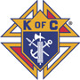**Knights of Columbus Corner**

**Holy Trinity Council No. 12353**

Monthly Theme: Family

**RAFFLE: Alberta Knights of Columbus 50/50**

* Visit: <https://www.rafflebox.ca/raffle/kocab/123>
* Sales Ends Friday, December 9th 2022

**NEXT BINGO: Friday, December 9, 2022 @ Parkway Bingo**

* 8775-51 Avenue NW
* AFTERNOON SHIFT FROM 10:30 AM TO 5:00 PM
* Brother Knights, Wives, Daughters, Sons, Family Members and Parishioners over 18 years of age are encouraged to volunteer and to help at a bingo.

PLEASE let us know if you can help:

CONTACT: Dennis Stansfield, Bingo Coordinator

Cell Phone: 780-910-4626 (Leave a message)

E-Mail: [denstansfiled@shaw.ca](mailto:denstansfiled@shaw.ca)

**THANK YOU FOR HELPING!**

**\*\*\*\*\*\*\*\*\*\*\*\*\*\*\*\*\*\*\*\*\*\*\*\*\*\*\*\*\*\*\*\*\*\*\*\*\*\*\*\*\*\*\*\*\*\***

**Registering for FORMED is easier than ever:**

**1.** Go to formed.org/signup; click the 3rd button: I belong to a parish organization.

2. Select your parish: Enter Postal Code T6E 2A6 and select St. Anthony from the dropdown menu.

3. Register with your name and email address

4. Check that email account for a link to begin using FORMED.