The Twin Roman Catholic Parishes of
St. Agnes & St. Anthony
NINETEENTH SUNDAY IN ORDINARY TIME
YEAR A- AUGUST 13, 2023
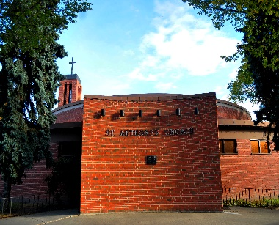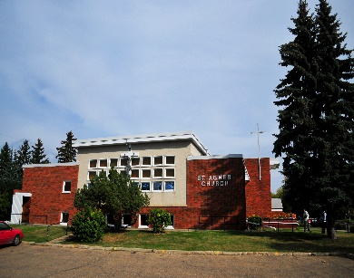

St. Anthony St. Agnes
10661-82 Avenue 10826-62 Avenue
Edmonton, AB T6E 2A6 Edmonton, AB T6H 1N1
Ph: 780- 432-0611 Ph: 780- 432-0611
Fax: 1-825-514-9046

Office Hours: Monday – Friday
9:00 am – 12 Noon and 1:00 pm – 4:00 pm

E-Mail: stanthony.edm@caedm.ca
Parish website: twinparishes.caedm.ca

St. Agnes & St. Anthony Joint Mission Statement
As sharers in the mission of Jesus Christ, we are committed to spreading the Gospel and building up the kingdom of God in our homes, in our parishes, and in the communities in which we live.
***************************************************************
St. Agnes & St. Anthony Parish Staff:
Pastor Rev. Varghese Munduvelil CFIC
Deacon Guy Germain
Deacon Michael Pucylo
Deacon Ramon Morales
Business Manager Don Wong
Administrative Assistant Florentina Suce
Custodian Bruce Huynh
******************************************
Twin Parishes Financial Pulse
Full Year
August 05/06 Actual YTD Budget
Sunday, Holy Day $13,889 $250,315 $395,000
Building Maint. Fund $ 645 $12,683 $30,000
Together We Serve $775 $14,907 $30,000
May God bless you in your response to His love.

70th Anniversary of St. Agnes Church
In celebration of the 70th Anniversary of St. Agnes Church mass will be Sunday, August 20, 2023 at 12:00 Noon by Archbishop Richard Smith. Followed by a Potluck Lunch in Merchant Hall. Everyone is welcome! Please bring sandwiches, veggies, fruit trays and finger food desserts to share.

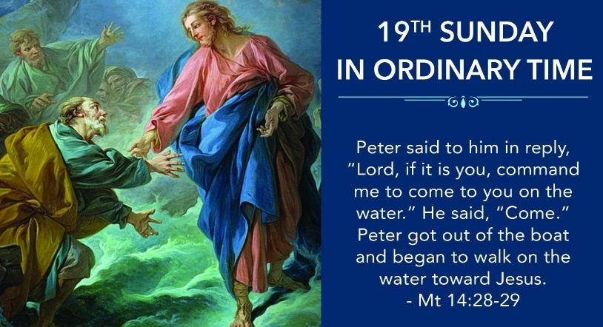
Twin Parishes Masses for the Week
Tuesday, August 15  Mass @ St. Anthony | 7:00 pm
Wednesday, August 16  Adoration @ St. Anthony  Mass @ St. Anthony | 5-6 pm  6:15 pm
Thursday, August 17  Mass @ St. Agnes | 9:00 am
Friday, August 18  Mass @ St. Agnes | 9:00 am
Saturday, August 19  Mass @ St. Agnes  Mass @ St. Anthony | 5:00 pm  7:30 pm
Sunday, August 20  Mass @ St. Agnes  Mass @ St. Anthony  Mass @ St. Agnes | 9:00 am  10:30 am  12 Noon

To all the parishioners who are interested in having their church donations by automatic withdrawal from their banks please email or call the parish office @ 780-432-0611 to register.

DONATE BUTTON
Parish website: twinparishes.caedm.ca

Here are three ways to give:
St. Agnes and St. Anthony would prefer if you use:
Pre-Authorized Giving Agreement Form
Envelopes can be dropped off or mailed to the parish office at:
St. Anthony,
10661-82 Avenue NW Edmonton,
AB T6E 2A6

Donate online:

Thank you for being a good steward of

St. Agnes/St. Anthony Parish.

Every gift is truly appreciated.

CHURCH DONATION E-TRANSFER
You can E-Transfer your church donation to StAnthonyEdm.etransfer@caedm.ca will be automatically deposited to the account of The Twin Roman Catholic Parishes of St. Agnes & St. Anthony at RBC Royal Bank. Thank you for your support and generosity.
SACRAMENTS

FIRST RECONCILIATION AND FIRST HOLY COMMUNION

Please call the parish office 780-432-0611 for more information and registration. Sessions will be every other Saturday from 10:00 am 12:000 PM at St. Agnes church hall. Deadline of registration is August 30, 2023.

CONFIRMATION PREPARATION CLASS –If your children are between the ages of 11 to 14, please call the parish office for more information and registration. Sessions will be every other Saturday at 1:00-3:00 PM at St. Agnes church hall. Deadline of registration is August 30, 2023

RCIA (Adapted for Children age 7 – 14)

RCIA (Rite of Christian Initiation for Adults – age 15 and above) Anyone who wants to become Catholic and Catholics who have not yet received First Communion and Confirmation, and anyone interested in learning more about RCIA please call parish office at 780-432-0611 to register. Session is every Wednesday @ 7:00 PM St. Anthony Padua Room.

MARRIAGE: Because the church is deeply concerned about each marriage, couples are asked to give a minimum of six months notice prior to the intended date of their wedding. Normally the parish boundaries determine in which parish marriage planning should take place.

FUNERAL: Family or designated person by the family should contact the Parish Office for funeral arrangements with the parish priest.

TWIN PARISHES OF ST. AGNES &
ST. ANTHONY PARISH PICNIC
Date: Sunday, August 13, 2023
Time: 1:00 PM
Venue: Parkallen Community Park
6510 – 111 Street NW
Bring Food to share!
EVERYONE IS WELCOME!
*****************************************

Twin Parishes of St. Agnes & St. Anthony 50/50 Fundraising of selling Raffle Tickets is now in full swing at both churches after all the weekend masses. Everyone can make a big difference by taking home a booklet and sell them to your relatives, friends and acquaintances. Please see Cathy Ehm @ St. Agnes or Lito Reyes @ St Anthony to get your booklets. Plenty of time to sell them, the draw date is on December 15th @ St. Agnes 1:00 PM. Cost $10/3 tickets $5/1 ticket. Thank you very much for your full participation. God bless!
Sinking Fear: Scott Hahn Reflects on the Nineteenth Sunday in Ordinary Time
How do we find God in the storms and struggles of our lives, in the trials we encounter in trying to do His will?
God commands Elijah in today’s First Reading to stand on the mountain and await His passing by. And in the Gospel, Jesus makes the disciples set out across the waters to meet Him.
In each case, the Lord makes Himself present amid frightening tumult—heavy winds and high waves, fire and earthquakes.
Elijah hides his face. Perhaps he remembers Moses, who met God on the same mountain, also amid fire, thunder, and smoke (see Deuteronomy 4:10–15; Exodus 19:17–19). God told Moses no one could see His face and live, and He sheltered Moses in the hollow of a rock, as He shelters Elijah in a cave (see Exodus 33:18–23).
The disciples, likewise, are too terrified to look on the face of God. Today’s Gospel is a revelation of Jesus’ divine identity. Only God treads across the crest of the sea (see Job 9:8) and rules the raging waters (see Psalm 89:9–10). And the words of assurance that Jesus speaks—“It is I”— are those God used to identify Himself to Moses (see Exodus 3:14; Isaiah 43:10).
Even Peter is too overcome by fear to imitate his Lord. His fears, Jesus tells him, are a sign of his lack of faith. And so it often is with us. Our fears make us doubt, make it hard to see His glory dwelling in our midst.
Yet, we should know, as we sing in today’s Psalm, that His salvation is near to those who hope in Him. By faith we should know, as Paul asserts in today’s Epistle, that we are heirs to the promises made to His children, Israel.
We must trust that He whispers to us in the trials of our lives—that He who has called us to walk along the way of His steps—save us whenever we begin to sink.
**********************************************
THE ANNUAL PILGRIMAGE AT SKARO
Monday, August 14th, 2023
6:30-7:30 pm Reconciliation
7:00 pm Rosary
7:30 pm Vespers (in Polish)
8:00 pm Mass at Grotto
The Blessed Sacrament Procession with lit candles will follow the blessing of the religious articles.
Tuesday, August 15th, 2023
10:00 am Mass at the Grotto with the Sacrament of the Sick
The Blessed Sacrament Procession with lit candles will follow the blessing of the religious articles.

